|  |
| --- |
| MINISTRY OF EDUCATION AND SCIENCE OF UKRAINE  NATIONAL TECHNICAL UNIVERSITY  «KHARKIV POLYTECHNIC INSTITUTE»  Department of Software Engineering and Management Information Technologies  List of laboratory reports  discipline « Fundamentals of Operating System »  Executed by: Chukwu Irele omike  Student of group KH-201.8ei.1  Checked by:  Prof. S. L  Gloskakova Anna Alexandrouna  Kharkiv – 2019 |

MINISTRY OF EDUCATION AND SCIENCE OF UKRAINE

NATIONAL TECHNICAL UNIVERSITY

«KHARKIV POLYTECHNIC INSTITUTE»

Department of Software Engineering and Management Information Technologies

Report from lab № 5

discipline « Fundamentals of Operating System »

Kharkiv

2019

**Task for laboratory work**

In the course of the work, it is necessary to study theoretical information related to user administration, as well as to carry out practical tasks and answer the quiz described below.

Read the contents of the files:



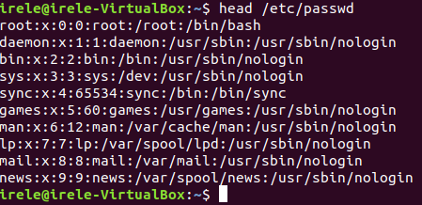

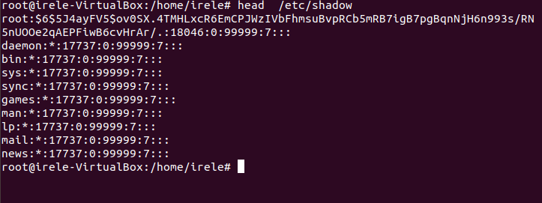

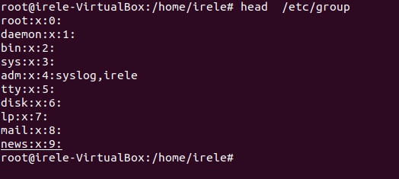

Create the following groups:

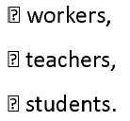

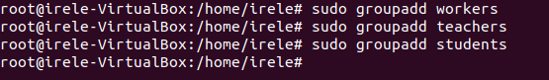

Create user user_[variant]_ N, where N =1, 2, .., 5, uid account must be equal ot 1000+N.

Users with N equal to 1 and 2 add to the group of workers manually making changes to the configuration file.

After adding users, check the /etc /group file for errors. Users with N equal to 3, 4 and 5 are added to the group students using the administration commands *.

If you have any questions about using a particular key, use the man command to get help:

***man [command name].***

Check the results.

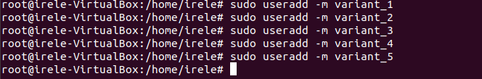

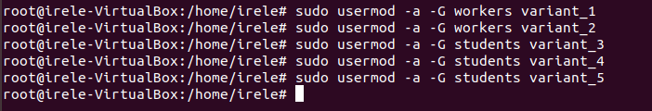

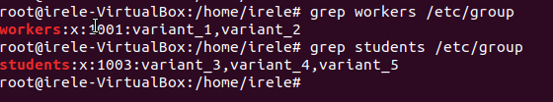

Create user teacher_[variant].

In the comment to the account there must be your first and last name.

The uid of the account must be 3000. Add the user to the teachers group.



For all users, set the password using the ***passwd*** command.

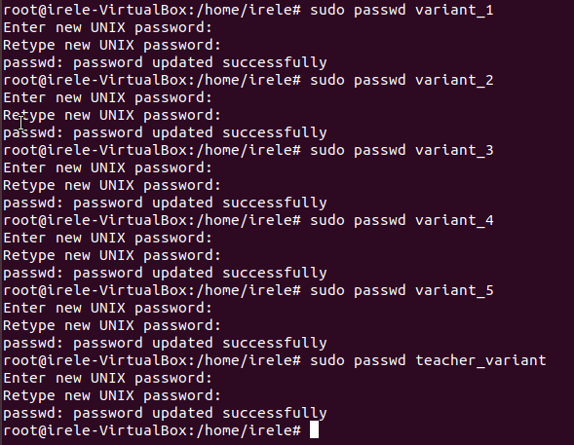

Create a labs directory in the root directory. In it, create the library and tests directories.



Create files book_[student name]_N and put it in library.



Create text file **test_[student name]**, and put it into **tests** folder. Files must contain a script: to create a user *user[variant number]* and to set password *pass[variant]*. Give the right to execute the file to the **Students** group users.

